- Introduction to Networks

Q.1 Draw a simple diagram (hand-drawn or digital) showing how your phone connects to Instagram, including your device, WiFi router, ISP, and Instagram server. Label each part and the connections?
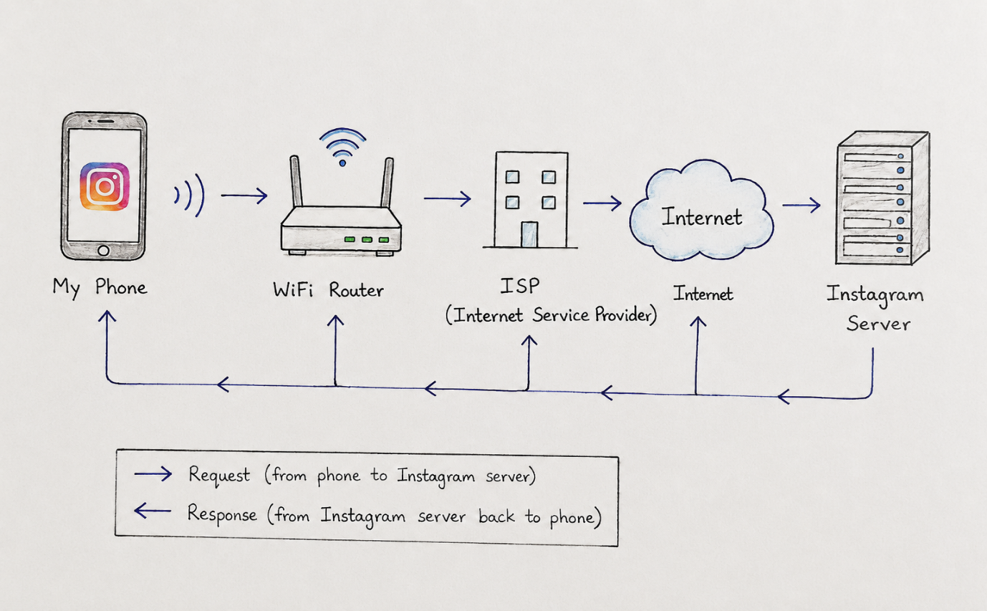

Q.2 List 5 devices you use or see daily that are part of a network (for example: smartphone, smart TV, WiFi router, laptop, smartwatch). For each, write what type of network it connects to (LAN, WAN, PAN, etc.)?

Device | Network Type | Example
- Smartphone | WAN | Mobile data / cellular network
- Laptop | LAN | College or home WiFi
- Smartwatch | PAN | Bluetooth connection to phone
- Smart TV | LAN | Home WiFi network
- Bluetooth Earbuds | PAN | Bluetooth connection to phone

Q.3 Explain the difference between the Internet and an intranet using an example from your college or a public WiFi you have used?

Internet: The Internet is a public worldwide network. Anyone with an Internet connection can use it to open websites and apps. For example, when I use public WiFi in a cafe or college and open YouTube or Instagram, I am using the Internet.
Intranet: An intranet is a private network used inside one organization. Only authorized people can access it. For example, a college student portal or internal lab website that is available only to students and staff can be part of an intranet.

Q.4 Pick any one app you use (like WhatsApp, Zomato, or Flipkart) and describe, in 4-5 lines, how data travels from your device to their server and back when you perform a search inside the app.<br><br><em><strong>Hint:</strong> Mention the devices and networks involved, and what happens when you hit 'search'.</em>?

- When I open Flipkart and search for "shoes", my phone sends the search request using WiFi or mobile data.
- The request goes through the WiFi router, ISP, and the Internet.
- It then reaches Flipkart's server, where the server searches its database for matching products.
- The server sends the search results back through the Internet to my device.
- Finally, the Flipkart app displays the products on my screen.

